HIST 406
Rebels and Romantics: Europe 1815-1870

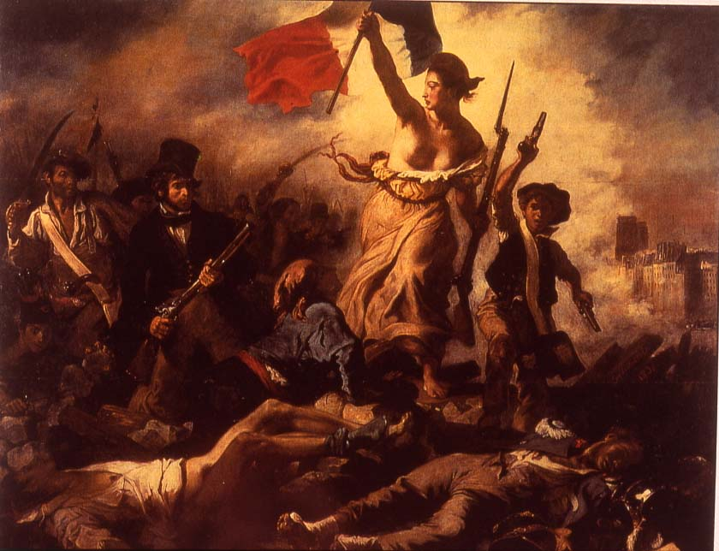
Delacroix, Liberty Leading the People, 1830

Spring 2017 MWF 9:30-10:20 AM UNIV 219
Professor Walton UNIV 323 Office Hours: MWF 10:30-11:30 and by appointment
awhitney@purdue.edu

This course covers European history from the final downfall of Napoleon in 1815 to the Franco-Prussian War of 1870 that led to the creation of the second German empire. Students will learn about topics like industrialization, romanticism, the slow and complicated decline of the aristocracy, the coming to power of the middle class (or bourgeoisie), the formation of the working class, the domestic ideal for women, prostitution, sexuality, masculinity, the Crimean War (1853-56), socialism, the revolutions of 1848, the changing status of Jews, early European imperialism, Darwinism, and the consolidation of the nation-state form.
The objectives of this course are to help students gain an in-depth understanding of selected developments in nineteenth-century European history that are significant in the modern world, and to cultivate their analytical, writing, and oral expression skills. To this end students will read, discuss, and write about several primary sources, that is, documents produced by eyewitnesses to nineteenth-century events, and secondary sources, recent works of scholarship that analyze the past. The format is largely seminar-style discussion, with some lectures and films, and several short papers. Each student will lead one discussion. Students will also engage in the process of developing a Digital Humanities project.
No prior knowledge about modern European history is required or expected. However, students are expected to keep up with the reading, attend class regularly, be prepared to discuss readings, lectures, and films as appropriate, and fulfill ALL assignments on time.

Required texts:
Honoré Balzac, Colonel Chabert
Friedrich Engels, The Condition of the Working Class in England
Fanny Lewald, The Education of Fanny Lewald: An Autobiography
Janet Browne, Darwin’s Origin of Species: A Biography
Giuseppe di Lampedusa, The Leopard
Robert Gildea, Barricades and Borders (3rd ed.) is a recommended overall history – not required.
Additional readings will be posted on Blackboard Learn or available online

Course requirements:
5 short papers on assigned readings (14% each) 70%
Participation in class discussion 20%
Digital Humanities project 10%

M 9 Jan Introduction to a revolutionary century; Napoleonic legacy

W 11 Jan Lecture on Restoration France and Regency England
Balzac, begin

F 13 Jan Social climbing, cynicism, and romanticism in Restoration France
Balzac, finish

M 16 Jan Martin Luther King, Jr. Day – no class

W 18 Jan Social relations in England; film Silas Marner

F 20 Jan More of Silas Marner
Hall (on Blackboard Learn) begin

M 23 Jan European society, family life, and religion in the early 19th c.
Hall (on Blackboard Learn) finish

W 25 Jan Romanticism in the arts, society, and politics
Hall finish if needed; wrap-up discussion of post-revolutionary society

F 27 Jan Research guidance, requirements; meet in computer lab SC 283
*Paper due on Silas Marner, Balzac, and Hall

M 30 Jan Industrialization in Europe and Engels’s social analysis in 1844
Engels, “To the Working Classes,”; “Introduction”

W 1 Feb Transformation of work and life
Engels, ch. 5 Results
Student leader:

F 3 Feb Family and gender in industrialization
Engels, ch. 6 Single Branches . . . Factory Hands
Student leader:

M 6 Feb Development of workers’ activism and socialism
Engels, ch. 8 Labour Movements
Student leader:

W 8 Feb Scenes from film: North and South
*Submit topic idea and preliminary bibliography

F 10 Feb Engels and Marx on proletarian revolution
Engels, ch. 11 Attitude of Bourgeoisie
Student leader:

M 13 Feb Revolutions of 1848; scenes from Les Misérables
*paper due on Engels

W 15 Feb Jews in nineteenth-century Europe
Lewald, pp, xiii-20

F 17 Feb Home life, girlhood, and childrearing practices in the middle class
Lewald, pp. 20-73
Student leader:

M 20 Feb Gender, sexuality, and the state in the nineteenth century

W 22 Feb German and Jewish in nineteenth-century Prussia
Lewald, pp. 74-135
Student leader:

F 24 Feb No class – work on Omeka projects

M 27 Feb Women’s lives in a romantic and revolutionary era
Lewald, pp. 139-187
Student leader:

W 1 Mar An ambitious young women confronts nationalism and feminism
Lewald, pp. 187-252
Student leader:

F 3 Mar Politics and a writing career
Lewald, pp. 252-311

M 6 Mar Queen Victoria and Victorianism

W 8 Mar Florence Nightingale, hero of the Crimean War, 1854-56
*Paper due on Lewald

F 10 Mar Implications of the Crimean War for European society and states
Lyons (on Blackboard); British newspapers online

13-17 Mar SPRING BREAK!!

M 20 Mar Indian revolt of 1857 – mutiny or national revolution?

W 22 Mar Different perspectives: European empire and effects on non-Europeans
Savage and Oude (on Blackboard)
Student leader:

F 24 Mar Liberalism and empire – changing views of British empire in India
Metcalf (on Blackboard)
Student leader:

M 27 Mar Science in the time of Victoria
Browne, ch. 1

W 29 Mar Thinking about change in nature
Browne, ch. 2
Student leader:

F 31 Mar Publishing Origin of Species 1859
Browne, ch. 3
Student leader:

M 3 Apr Public and scientific responses
Browne, ch. 4
Student leader:

W 5 Apr Darwin in film French Lieutenant’s Woman or Darwin. The Voyage that Shook the World

F 7 Apr Italian Risorgimento and Garibaldi
*Paper due on empire or Darwin

M 10 Apr Student presentations and peer reviews

W 12 Apr Student presentations and peer reviews

F 14 Apr Student presentations and peer reviews

M 17 Apr Student presentations and peer reviews

W 19 Apr Patriarchy and power in nineteenth-century Sicily
Lampedusa, ch. 1-2

F 21 Apr No class – Blackboard Learn discussion

M 24 Apr Nationalism, regionalism, and social change
Lampedusa, chs. 3-6
Student leader:

W 26 Apr The end of an era?
Lampedusa, chs. 6-8
Student leader:

F 28 Apr Bismarck and the unification of Germany

M 1 May *Paper due on Lampedusa

Course policies

Cell phones off in class; no texting during class; no taking calls during class.

Regular attendance is required. Additionally, students are expected to have done assigned reading and be prepared to discuss it on designated class days. The professor will provide guidance on preparing for discussions either orally in the previous class or with a handout. At least once during the semester, and more often on request, students will be informed of their approximate class participation grades. Criteria for grading class participation include the following:
- frequency (or quantity)
- accuracy in answering questions provided in advance
- insightfulness of comments, questions, or answers
- appropriate application of knowledge from other class materials
- ability to further discussion in new, constructive directions.
Be sure to bring to class copies of the readings under discussion on a given day.

Participating in class discussions can be stressful for some individuals, but there are good pedagogical and professional reasons for making this a significant component of the course. Posting responses on Blackboard Learn will often be an option for students, and sometimes will be a requirement for the entire class. If necessary, reading quizzes or short response papers will be added.

Frequent absences will lower a student’s final grade; that is, more than 3-5 absences is cause for concern. More than 6 absences will lead to a failing grade for the course.

Short papers should be 4-5 pages long (double-spaced), and specific topics will be articulated in class or in a handout. Papers must be submitted at the beginning of class on the due dates and on SafeAssign; late papers are accepted until 5:00 P.M. on the due date. Students are encouraged to meet with the professor before paper due dates to discuss and review paper drafts. Failure to submit a paper on time may result in a failing grade in the course.

Plagiarism or any form of academic dishonesty will most likely result in an F for the course, and the relevant materials turned over to the Dean of Students Office. Plagiarism means reproducing or paraphrasing the words or ideas of someone else without proper attribution, and passing this work off as one's own. Students are expected to produce their own, original work, and to cite accurately all relevant materials. All of the written assignments for this course are designed to help students avoid plagiarism, and handouts will offer specific information on proper referencing of other people's words and ideas. See also www.purdue.edu/studentregulations/student_conduct/regulations.html

This syllabus provides the basic framework and scheduling for the semester, but slight changes in content and scheduling may occur for the convenience of students as the semester progresses. For example, the syllabus will be updated to include the names of student discussion leaders, and it may be necessary to add another lab session or alter the schedule of student presentations. Assigned textbooks and paper assignments will remain the same. We need to be flexible about the Omeka S projects. Any changes to the syllabus will be announced in class. Students are individually responsible for everything that transpires in class, including changes to the syllabus, whether or not the student is present. Absence is not an excuse.

In the event of a major campus emergency, course requirements, policies, deadlines, and grading percentages are subject to changes that may be necessitated by a revised semester calendar or other circumstances beyond the instructor’s control. Students may contact the professor at the e-mail address above, or check the course on Blackboard Learn. See also http://www.purdue.edu/emergency_preparedness

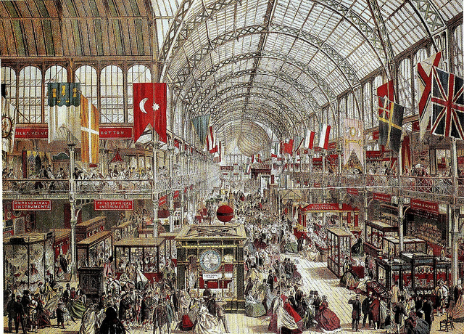
Crystal Palace Exhibition, London, 1851

